For Question 1 - Tray calculation for R = 1.5xRmin = 14 (for Q2 = 14 - 2 = 12)

For Question 4 – No. of trays = 13

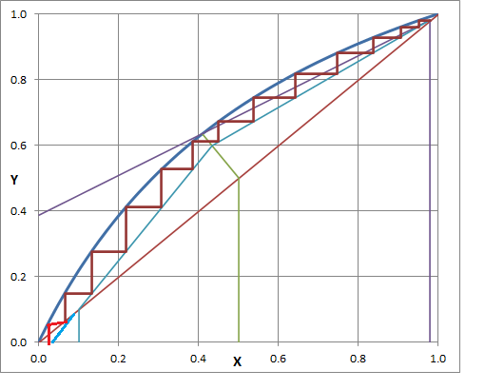

For Question 5 – No. of Trays = 12

